**Project Title**

Kura Labs Deployment 1.1

**Description**

Demonstrate your ability to run a Jenkins build and manually deploy to Elastic Beanstalk.

**Issues and Outcomes**

This deployment ran much smoother than yesterday. I was able to deploy Jenkins successfully.

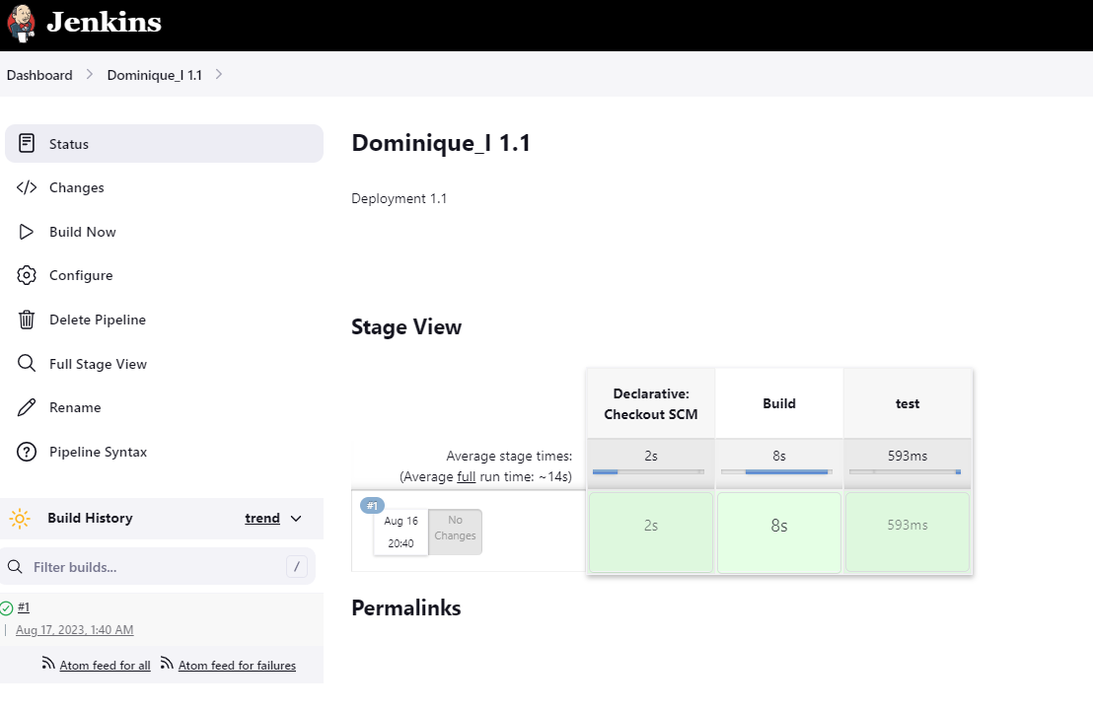

The main issue that I ran into was with my zipped folders, which is why I wasn’t able to select the “ElasticEC2” option when setting up my Python Shortener on EB per the instructions.

What I did to fix this was create a new compressed zip file that included my downloaded files from the GitHub repository. Once I fixed this, I was able to proceed through the instructions and run EB successfully.

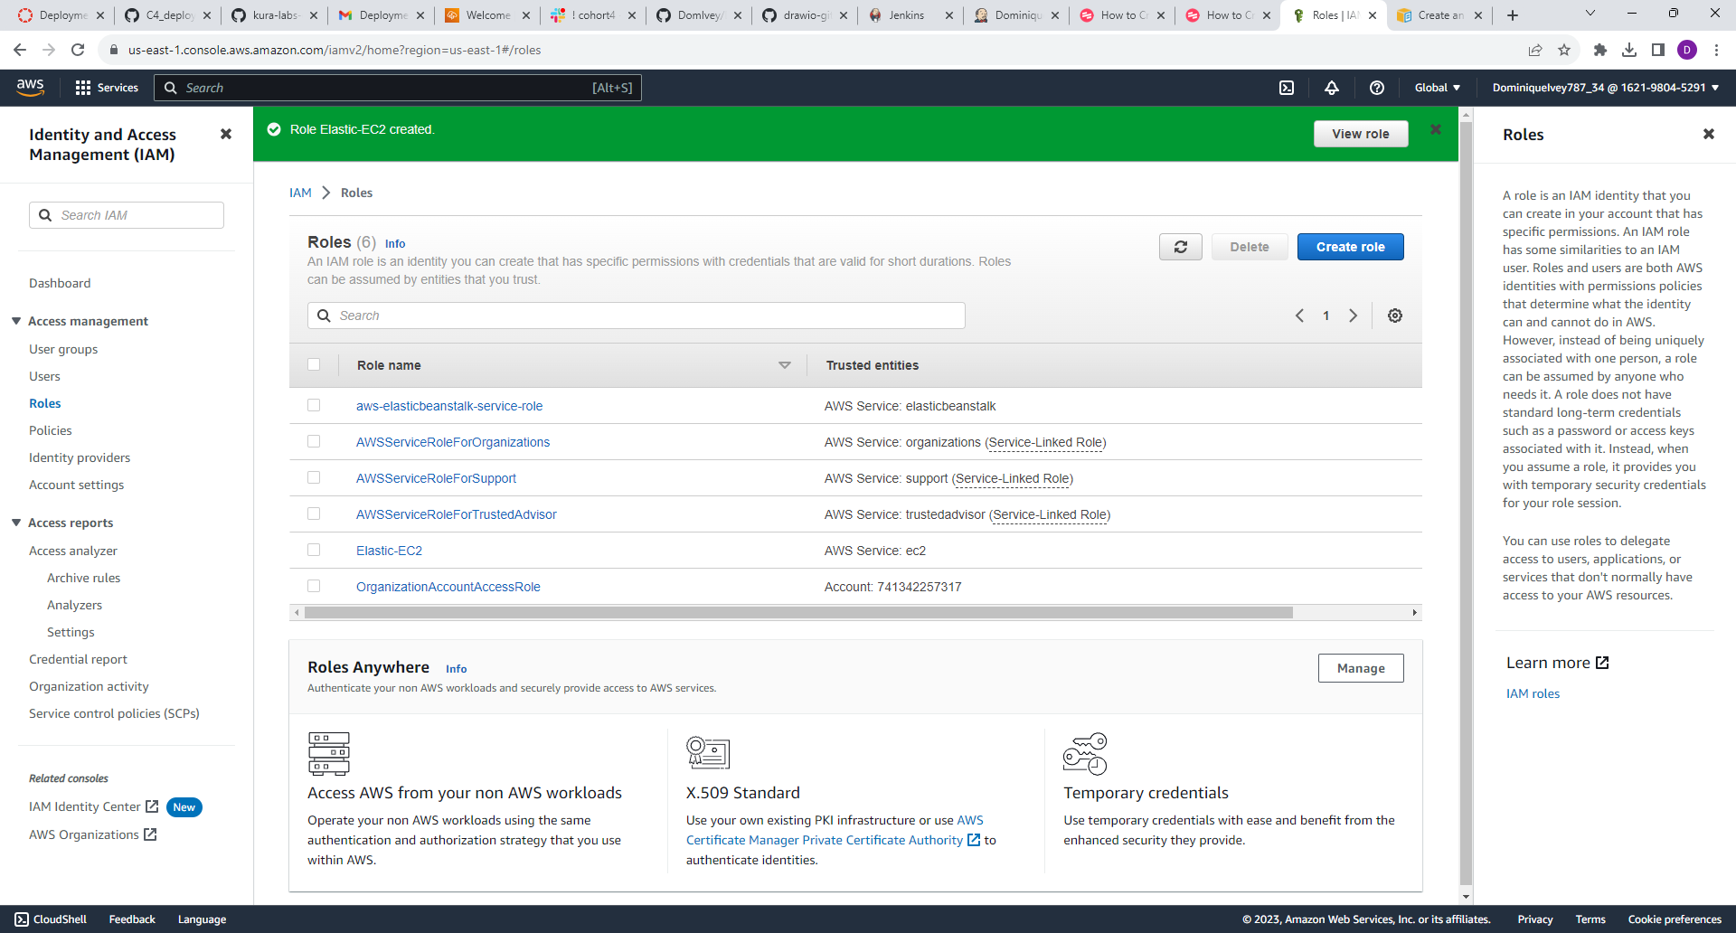

**Installing**

* Downloaded Instructor’s files from GitHub and reuploaded to my GitHub repository.
* Created a new zip file

**Programs Used**

* Jenkins
* AWS Elastic Beanstalk
* GitHub
* Chat GPT
* Scribe

**Help**

I used Chat GPT to help find out why AWS EB had a degraded health status

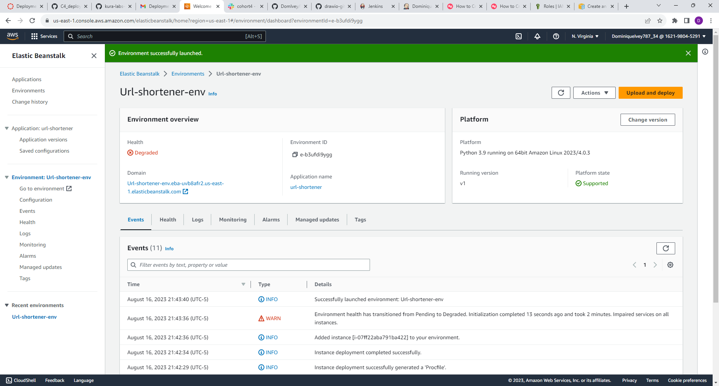

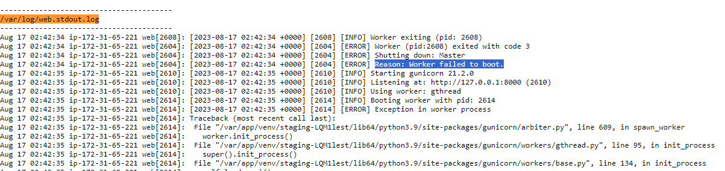

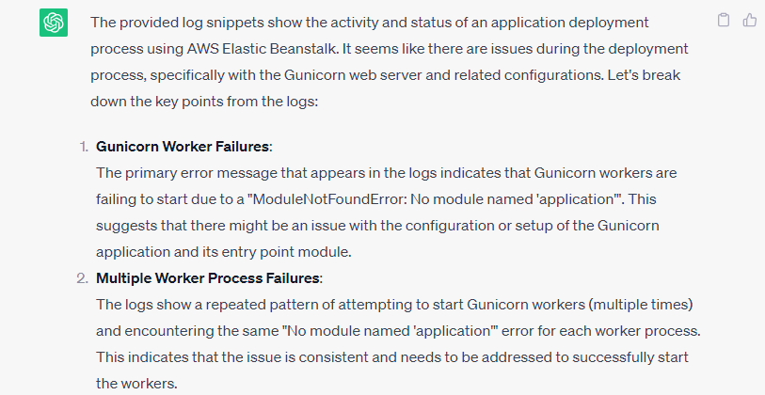

**Author**

Dominique Ivey